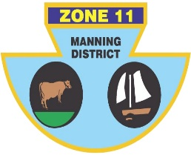
ZONE ll (MANNING DISTRICT)
BOWLING ASSOCIATION INC
2/76 Old Bar Road Old Bar 2430 Phone 0458 047 848 ABN: 21 505 810 214

OVER 70s INTER-ZONE SIDES CHAMPIONSHIP

Congratulations to the following players who have been selected to represent Zone 11 in the Over 70s Inter-Zone Sides Championship to be held at South Tamworth Bowling Club on 10, 11 April 2024.

LEAD | Harvey PHILLIPS (OB) | Jeff MOYES (F) | Robert AUSTIN (TL)
SECOND | Michael CUTTING (TB) | Vic MCGLASHAN (F) | Terry MALONEY (H)
THIRD | Noel JAMES (TB) | George MCCARTNEY (TS) | Marko PENDELJ (TS)
SKIP | Kevin ROBINSON (F) | Peter SCHROEDER (F) | Errol RUPRECHT (CW)

MANAGER: TBA

Players will be contacted individually with the complete details.

Mick Kilkeary
Zone 11 Secretary / Treasurer

