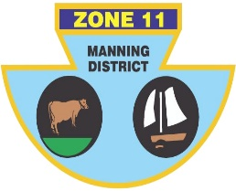
ZONE ll (MANNING DISTRICT)
BOWLING ASSOCIATION INC
PO Box 358 , Taree 2430 Phone 0458 047 848 ABN: 21 505 810 214

Congratulations to the following players who have been selected to represent Zone 11 in the Pat Geary Memorial Fixture against Zone 2 (Newcastle), Zone 6 (Hunter) and Zone 14 (North Coast) on Saturday 25th and Sunday 26th November 2023.

LEAD | SECOND | THIRD | SKIP
P Cassar | T Maloney | D Webster | S White
B Wilson | A Clements | J Aurisch | M Gosper
S Pell | P Schroeder | C Hebblewhite | J Cassidy
H McGuire | D Jessup | C Colligan | A Brymer

Reserves in no particular order and only if required:
M Pendelj, B Threadgate, E Ruprecht, R Hagan, R Austin, J Morse
Venue: Port City Bowling Club
Program: Three games of 21 ends; two on Saturday, starting at 10.00 am (Cards called @ 9.45 am, roll up @ 9.50 am) and one game on Sunday morning starting at 9.00 am (Cards called @ 8.45 am, roll up @ 8.50). Lunch follows 1st game on Saturday and after Sunday morning game.

Errol Ruprecht
Chairman of Selectors

