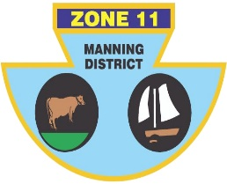
ZONE ll (MANNING DISTRICT)
BOWLING ASSOCIATION INC
PO Box 358 , Taree 2430 Phone 0458 047 848 ABN: 21 505 810 214

SENIOR INTER-ZONE SIDES CHAMPIONSHIP

Congratulations to the following players who have been selected to represent Zone 11 in the Senior side at the Inter-Zone Sides Championship to be held at Maitland City and Lorn Park Bowling Clubs on Tuesday 23rd May to Thursday 25th May 2023.

LEAD | Marco PENDLJ (TS) | Robert AUSTIN (TL) | John BEACH (Snr) (TL)
SECOND | Noel JAMES (TB) | Steve NEWMAN (TB) | Col HEBBLEWHITE (G)
THIRD | Peter SCHROEDER (F) | Errol RUPRECHT (TW) | Steve SWAN (TB)
SKIP | George McCARTNEY (TS) | Daryl WEBSTER (OB) | Bob HAGAN (TL)

MANAGER: TBA

RESERVES (IN NO PARTICULAR ORDER): Terry MALONEY (H), Stan ZDEBSKI (TB), Grant McKIRDY (TB), Ian LAWRENCE (F).

Zone 11 will be playing at Maitland City against zones 2, 8 and 13. Play commences at 8.30am on Tuesday 23 May.

Accommodation has been booked at the Old Maitland Inn, 279 New England Highway Rutherford. Further details regarding the event will be provided to selected players once they become available.

IF YOU ARE UNAVAILABLE, PLEASE CONTACT ERROL RUPRECHT ASAP ON 0424 371 429
Errol Ruprecht
Chairman of Selectors

