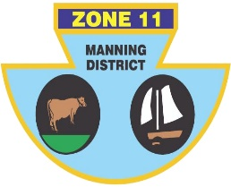
ZONE ll (MANNING DISTRICT)
BOWLING ASSOCIATION INC
PO Box 358 , Taree 2430 Phone 0458 047 848 ABN: 21 505 810 214

OPEN INTER-ZONE SIDES CHAMPIONSHIP

Congratulations to the following players who have been selected to represent Zone 11 in the Open side at the Inter-Zone Sides Championship to be held at Maitland City and Lorn Park Bowling Clubs on Saturday 27th May to Monday 29th May 2023.

LEAD | Peter CASSAR (H) | Trevor COSTA (H) | Matt PEARCE (H)
SECOND | Ash BRYMER (TB) | Craig COLLIGAN (H) | Keeden McGUIRE (F)
THIRD | Jason AURISCH (TB) | Jason CASSIDY (G) | Dominic RILEY (F)
SKIP | Shannon WHITE (F) | Clinton DOUST (F) | Martin GOSPER (F)

MANAGER: TBA

RESERVES (IN NO PARTICULAR ORDER): Daniel JESSOP (TB), Michael CHISLETT (H).

Zone 11 will be playing at Lorn Park against zones 16, 13 and 3. Play commences at 8.30 on Saturday 27 May.

Accommodation has been booked at the Old Maitland Inn, 279 New England Highway Rutherford. Further details regarding the event will be provided to selected players once they become available.

IF YOU ARE UNAVAILABLE, PLEASE CONTACT ERROL RUPRECHT ASAP ON 0424 371 429
Errol Ruprecht
Chairman of Selectors

