BowlsLink Pennant Training Guide

• 1 - Logging In
• 2 - Finding the Competitions
• 3 - How to Import Players
• 4 – Matching Skips
• 5 – How to Enter Results
• 6 – How to Confirm Results
• 7 – Import a Previous Team

1 - Logging In
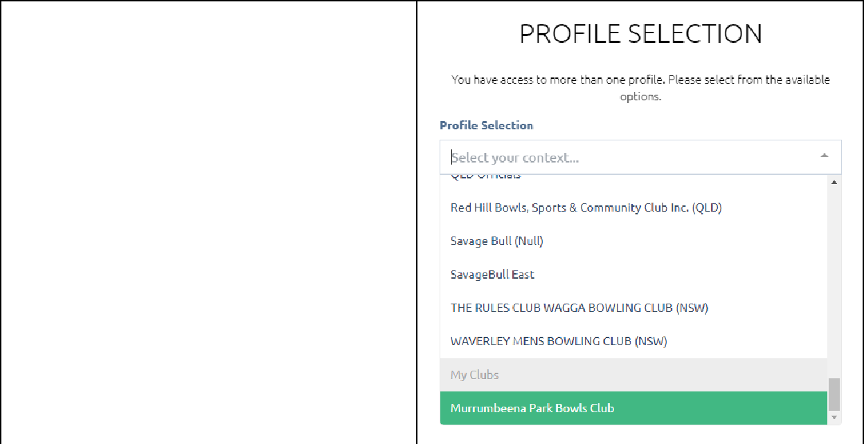

Login into https://www.bowlslink.com.au

Select your club under the My Clubs heading.

If you don’t have any administration levels it will log you straight into the correct profile.

2 - Finding the Competitions

Go to Competitions

Depending on the level of access you have, the competitions you can put teams and scores into will be in either of two places.
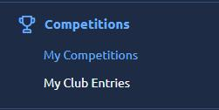

- Player/Team Manager given access to their own team only. Click on My Competitions.

- A Person with access to the Club Administration in BowlsLink. Click on My Club Entries.
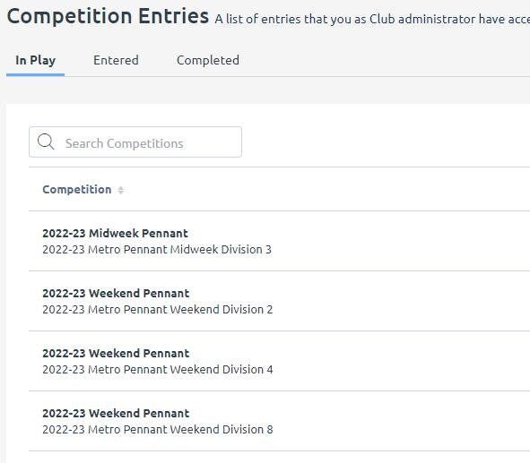

The Pennant Competitions will appear under ACTIVE or IN PLAY Tab.
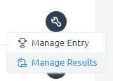

Select the ACTIONS … button and MANAGE RESULTS.
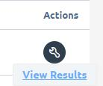

Select the appropriate Fixture round with the ACTIONS … and VIEW RESULTS

3 - How to Import Players

This step should be completed prior to the game.
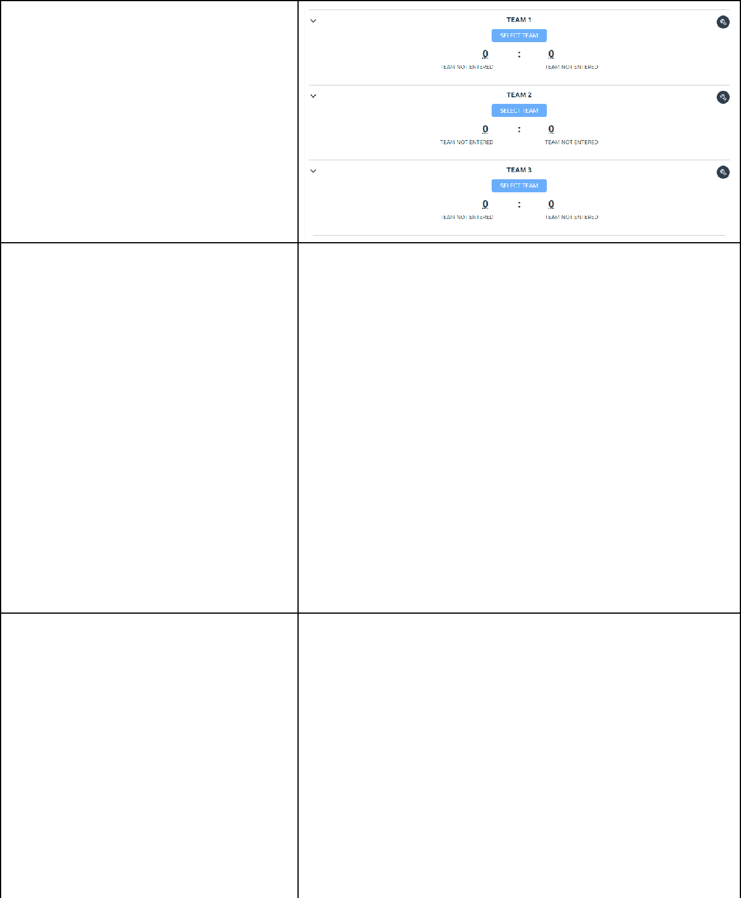

Under each Team is a SELECT TEAM Box.

Click one at a time to start importing players under each team.
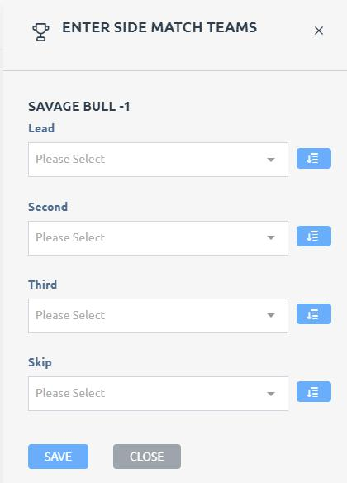

ENTER SIDE MATCH TEAMS

First week of competition, will need to import the players from the membership list to the competition.

Use the Blue Buttons to IMPORT players from the membership list into the required positions.
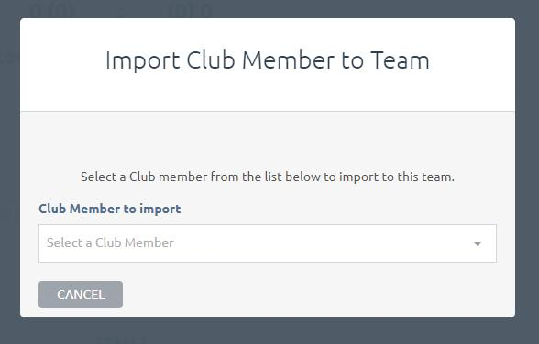

A pop up box will appear.

The drop down list will have all the members from the membership list.

TIP: Start typing the players name and it will reduce the list.

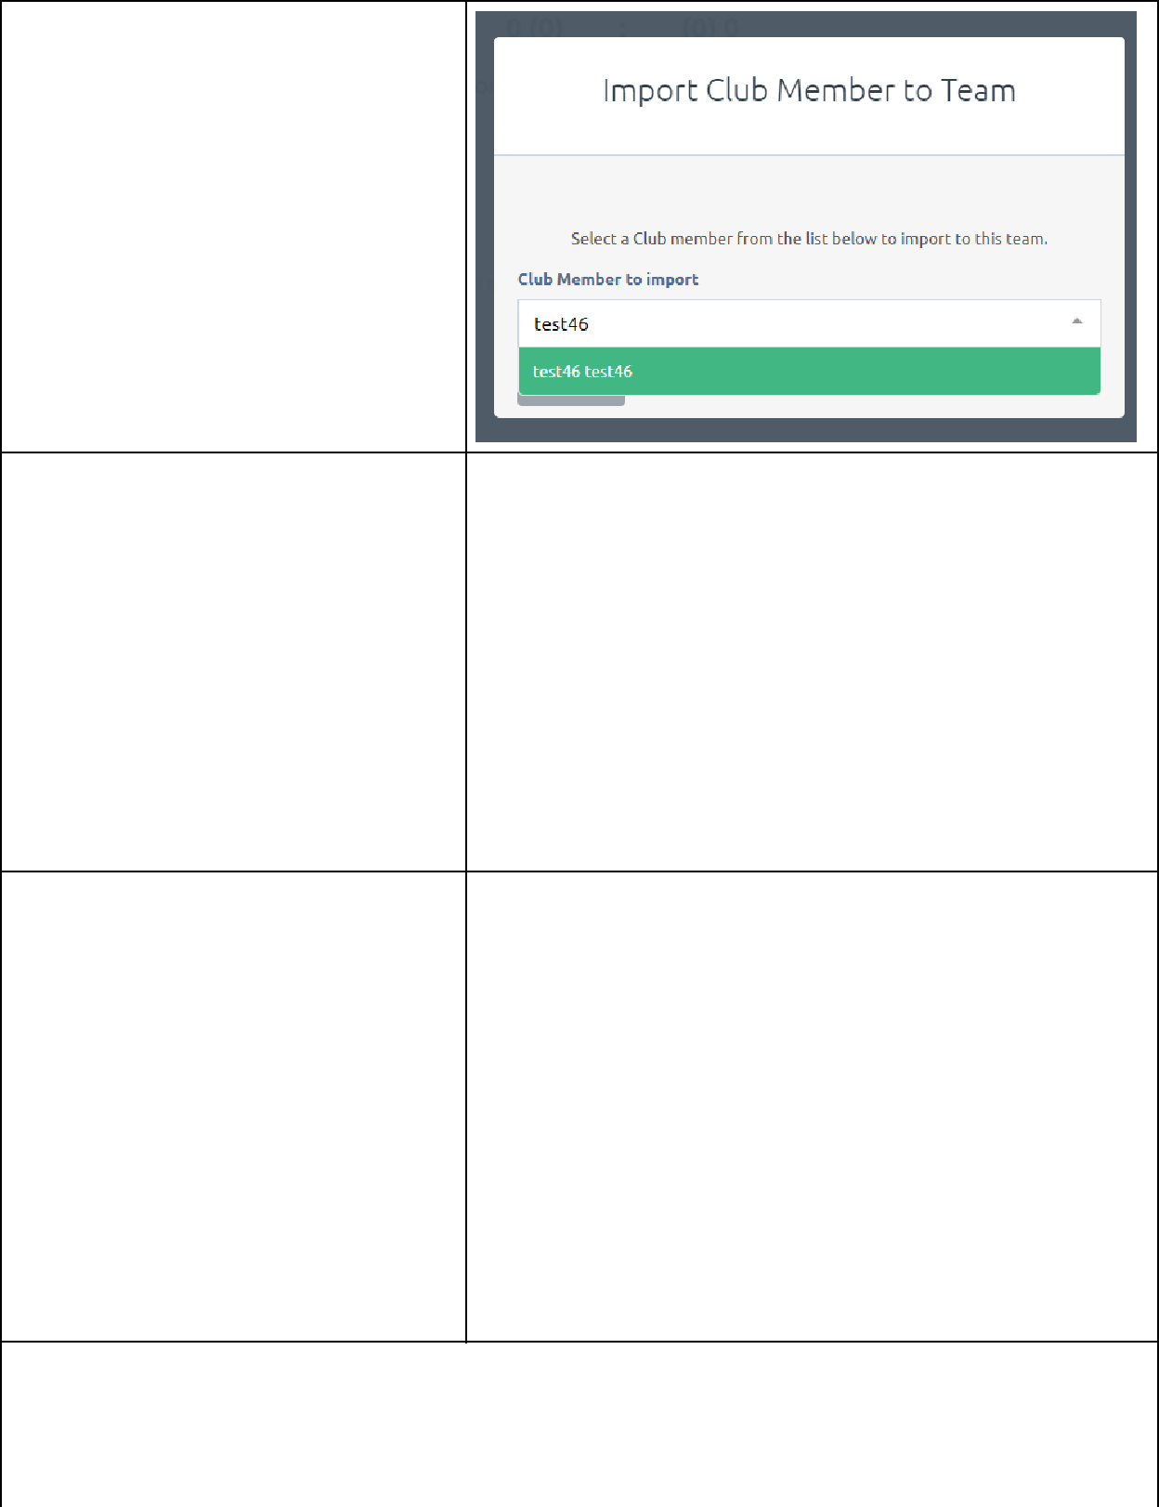

The player will be highlighted green, select them.
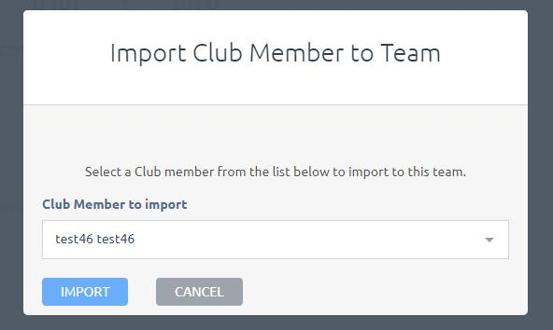

Click IMPORT.

Repeat this process for all Rinks.
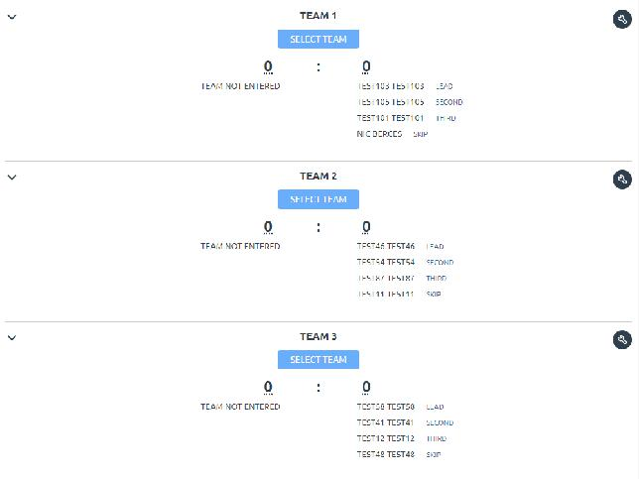

Once your side has been put in, you are good to go. Can still make changes if required.

If the SELECT TEAM is not visible, click the spanner on the appropriate team and can chose MANAGE TEAMS.

HINT: If the team is playing short UN-PLAYED can be selected from the Member List for that position

NOTE: Importing/Selecting Players may not need to be done in subsequent weeks. See Item 5

4 – Matching Skips

The HOME team is responsible for matching the TEAMS who play each other.
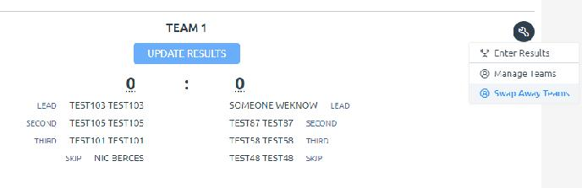

If the teams in the system do not match then click the spanner against the team. Select SWAP AWAY TEAMS
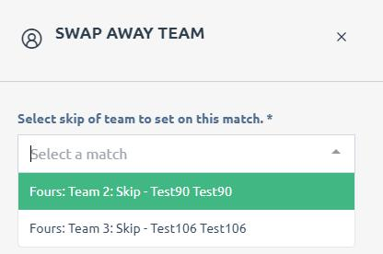

Find the correct SKIP from the available list using the drop down arrow then select SWAP
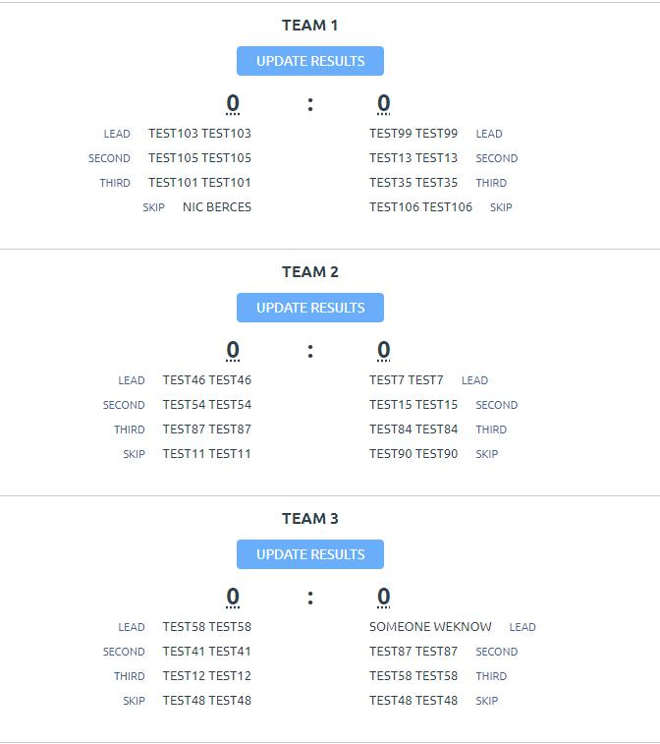

Once selected the AWAY TEAM will now swap positions. i.e. from Team 4 to Team 1.

Repeat this process for as many teams as required.

5 – How to Enter Results

Only the Home team can put results in. Select UPDATE RESULTS
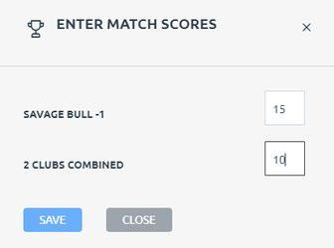

Enter the scores and remember to select SAVE
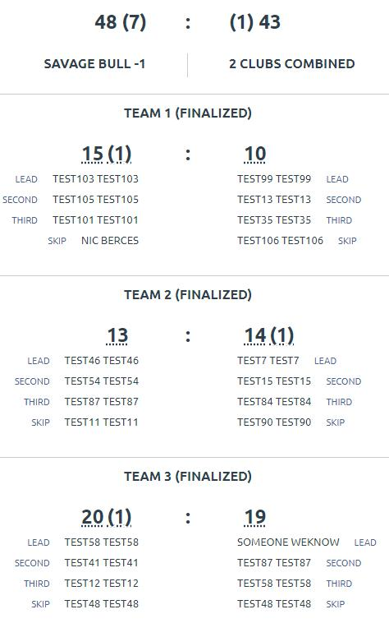

Repeat this process for all Rinks the system will automatically calculate the totals.

Down the bottom of the page, you will see a grey box, saying the results are pending until the AWAY team
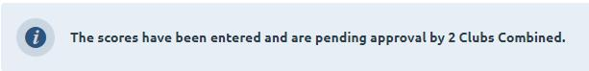
CONFIRMS.

If any changes are required, the home team can still do this by going to the team that needs changing.
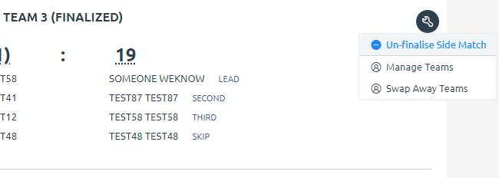

Click the SPANNER and choose UN-FINALISE SIDE MATCH.

This will un-finalise the team, which you can choose UPDATE RESULTS and change the results.

6 – How to Confirm Results

For the ladders to be updated away teams will be required to confirm the results.

The away team needs to log in and follow the steps above to get into the right round game.
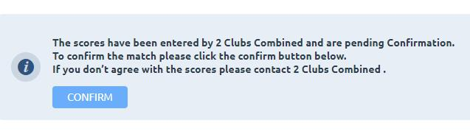

At the bottom of the screen is a confirm button, this option is only available to the away sides.

Once Confirm has been pressed neither the home nor away sides can make any additional changes. Please ensure that all details are correct prior to confirmation. The only person who can make changes after confirmation are Competition Administrators.

7 – Import a Previous Team

After Week 1 of a Pennant
Competition Teams can be Imported
from Previous Rounds.
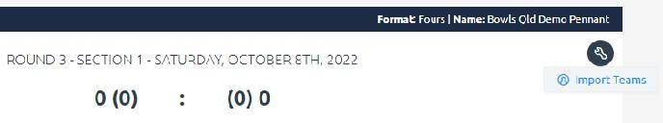

Login to the upcoming match as per previous steps.

Click the SPANNER at the top of the
page next to the Round and Date
details select Import Teams
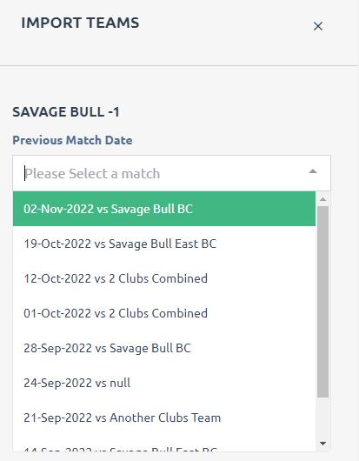

Use the drop down arrow to pick a previous match date then select

IMPORT TEAMS
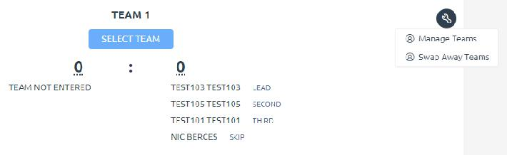

The players from this round will now appear, these can still be changed by selecting SELECT TEAMS or clicking the Spanner against the team and choosing MANAGE TEAMS.

