Adding Ladies to Pennant Teams in BowlsLink

If you have ladies playing in the Open Pennant this year and are not linked to the Men’s club, you will need to add them manually to the entry players list. The below steps walk you through this process. Make sure you have their National ID number from them.

Go to https://bowlslink.com.au
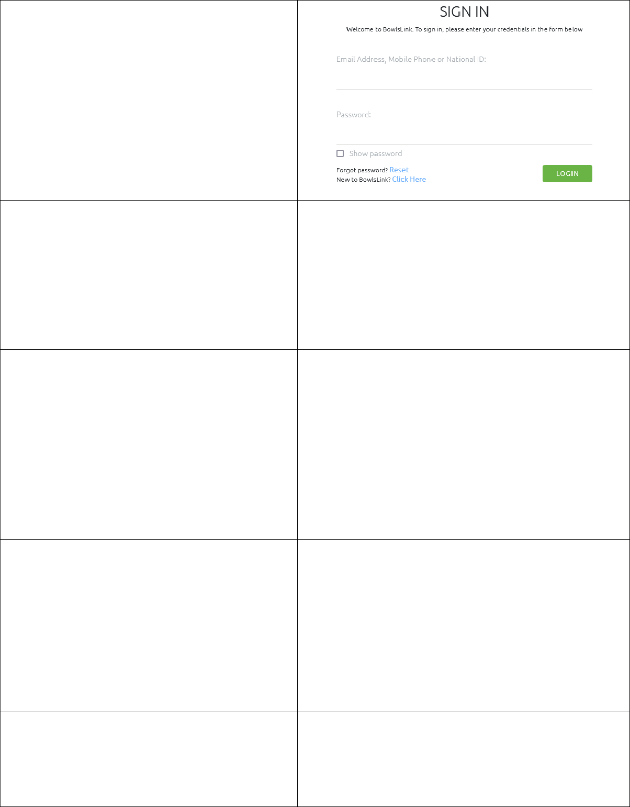

Select your Personal Club Membership profile. Go to Competitions – My
Competitions or My Club Entries. Depending on what access you have to BowlsLink.

Your Competitions will appear under IN PLAY.
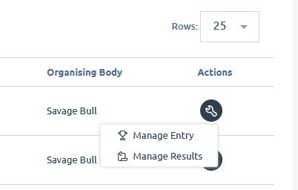
This step should be completed prior to the game. Using the SPANNER … select

MANAGE ENTRY

Under the PLAYERS Section, click the pencil.
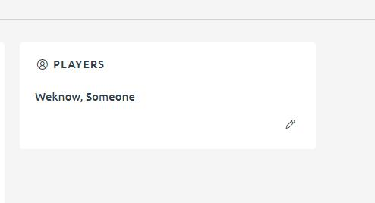

Click on + ADD PLAYER
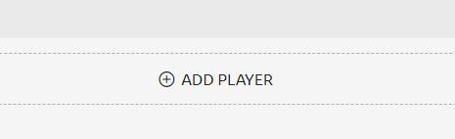

An ADD PLAYER box will appear, from the drop drown list. Select the option – Someone Else.
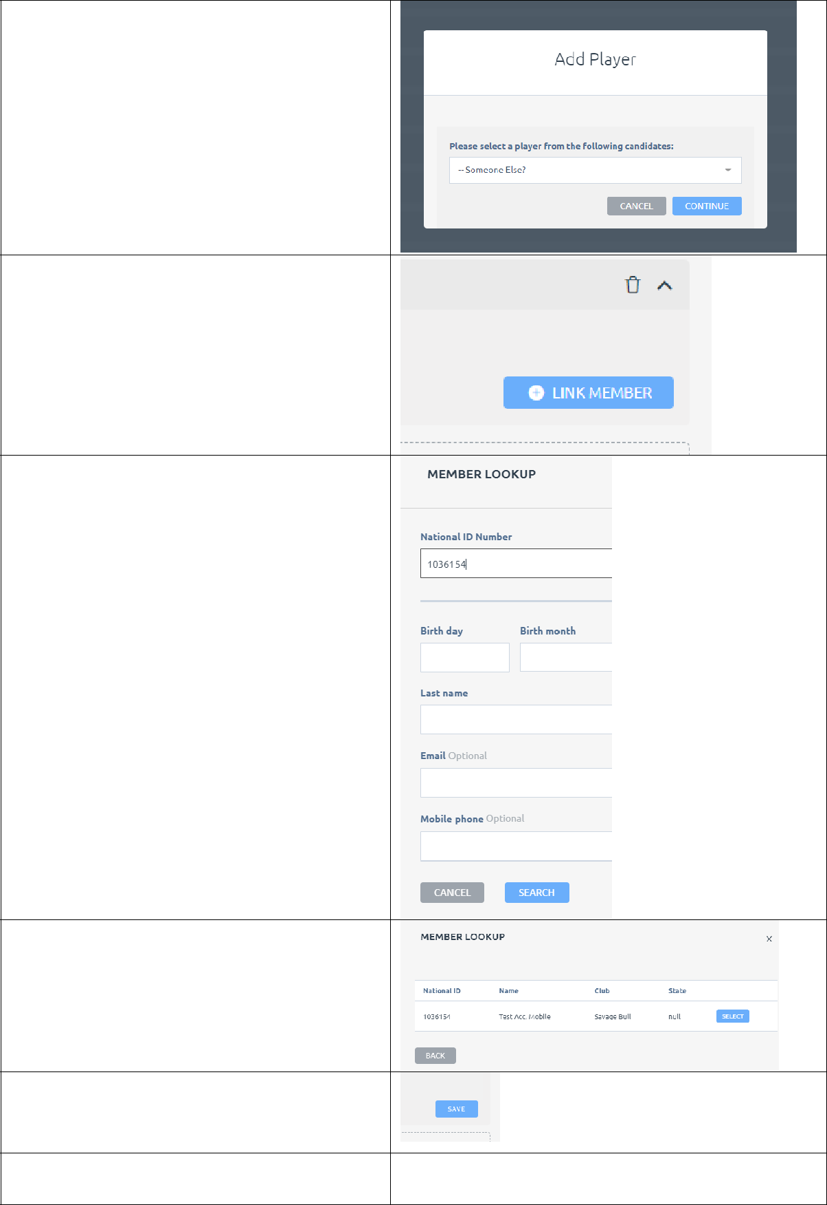

Then click CONTINUE

Scroll down until you find the new Player Box. It will say PLAYER XX.

Click on it to open it up and then should see a + LINK MEMBER box. Click it.

Add the Ladies National Membership Number in the National ID Number box and then click Search.

A confirmation box will appear to confirm that is the member you are wanting to add. If correct, click SELECT.

It will then prefill all the members details, scroll down until you see the SAVE button and then click SAVE.

Continue the above steps for all players.

