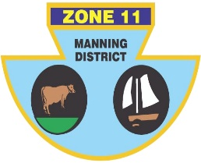
ZONE ll (MANNING DISTRICT)
BOWLING ASSOCIATION INC
PO Box 358 , Taree 2430 Phone 02 6553 3330 ABN: 21 505 810 214

Congratulations, you have been selected to represent Zone 11 in the Senior side at the Inter-Zone Sides Championships to be held at South Tamworth,West Tamworth and Tamworth City Bowling Club from the 17th to 19th May.

 | TEAM 1 | TEAM 2 | TEAM 3
LEAD | Tony HINTON (CWB) | Wayne WRIGHT (TB) | Tony GORRIE(SP)
SECOND | Peter SCHROEDER (F) | Barry DIXON (F) | Brian WILSON (F)
THIRD | Noel JAMES (TB) | Col HEBBLEWHITE (G) | Geoff PELL (F)
SKIP | Dennis HOYE (OB) | David RICHARDSON (TB) | G McCARTNEY (SP)

Reserve: Barry DIXON (F) Errol RUPRECHT (CWB)
MANAGER: Harry Williams

TRAVEL: Players to arrange their own transport, to arrive on the Sunday 16th May.

VENUE: Section play Tamworth City 8.30am,1pm 17th & 18th 8.30am with all finals 18th 1pm 19th am,pm at South Tamworth.

ROLL-UP: At Tamworth City Bowling Club, on the 16th May between 3-4 p.m.

ACCOMODATION The cost per player is TBC for the three nights accommodation, payable to Zone 11 Manning District Bowling Association via EFT to
BSB 062 540, Acc. No. 10273918
Room Allocations as follows;

MEALS: Breakfast and lunch will be provided by the Zone. All evening meals will be at the players expense.

IF YOU ARE UNAVAILABLE PLEASE CONTACT Shannon white 0431450168, ASAP.

Shannon White
Chairman of Selectors

