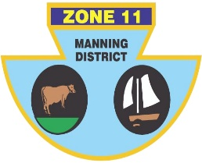
ZONE ll (MANNING DISTRICT)
BOWLING ASSOCIATION INC
PO Box 358 , Taree 2430 Phone 02 6553 3330 ABN: 21 505 810 214

The following players have been selected to represent Zone 11 in the Dooker/Eggart Shield, against Zone 14, on Sunday 21st February, 2021.

OPEN
LEAD | Matt PEARCE (H) | Warren COCKSEDGE (TL) | Trevor COSTA (H)
SECOND | Peter CASSAR (H) | Ashley HINTON (CWB) | Ash Brymer(TB)
THIRD | Phil Scott-Young (PP) | Jason Cassidy (G) | Jason AURISCH (TB)
SKIP | Shannon WHITE (F) | Martin Gosper(F) | Shane Globits(BH)

Reserve: M Pole(F), Craig COLLIGAN (H), D Jessop(BH)

SENIORS
LEAD | Bob O’MAHONY (CWB) | M Boyd (B) | Robert AUSTIN (TL)
SECOND | Tony HINTON (CWB) | S Swan (TB) | Errol RUPRECHT (CWB)
THIRD | Noel JAMES (TB) | Dave RICHARDSON (TB) | Geoff PELL (F)
SKIP | Rex JOHNSTON (TB) | R Logan(TB) | Peter SCHROEDER (F)

Reserve: Barry DIXON (F),M Aldridge (F), C Hebblewhite (G)
Manager: Harry Williams
Venue: Forster Bowling Club
Program: 2 games of 18 ends, commencing at 9.00 a.m. Players to arrive no later than 8.15 a.m. Lunch will be provided.
Transport: Players to arrange own transport.
IF YOU ARE UNAVAILABLE PLEASE CONTACT Shannon White ASAP ON 0431450168

Shannon White
Chairman of Selectors

