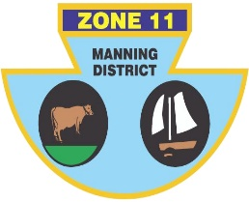
ZONE ll (MANNING DISTRICT)
BOWLING ASSOCIATION INC
PO Box 100 Old Bar 2430 Phone 02 6553 3330 ABN: 21 505 810 214

The following players have been selected to represent Zone 11 in the Pat Geary Shield against Zone 2, Zone 6 and Zone 14, at Soldiers Pt. Bowling Club on the 21st and 22nd of November.

 | TEAM 1 | TEAM2 | TEAM 3 | TEAM 4
LEAD | Matt PEARCE (H) | Nathan BUTLER (TL) | Kris MURTAGH (TB) | Noel JAMES (TB)
SECOND | Warren COCKSEDGE (TL) | Peter CASSAR (H) | Ash BRYMER (TB) | Peter  SCHROEDER (F)
THIRD | Shane GLOBITS (BH) | Martin GOSPER (F) | Jason AURISCH (TB) | Steve PELL (F)
SKIP | Shannon  WHITE (F) | Dominic RILEY (CWB) | Steve HARRIS (TB) | Rex  JOHNSTON (TB)

Reserves: Craig COLLIGAN (H) AND Ashley HINTON (CWB). Will be notified if required to attend.
Manager: Shannon White

